Seeed ESP32 C3 Microcontroller Documentation
Flashing device (link):
- Plug in while holdiong B to enter boot loader mode
- Install esptool w/ pip ($pip install esptool)
- Launch Thonny IDE
- Tools -> Configure IDE -> esptool
- Install CircuitPython to device port (If not showing unplug and reinsert entering bootloader mode)
  - 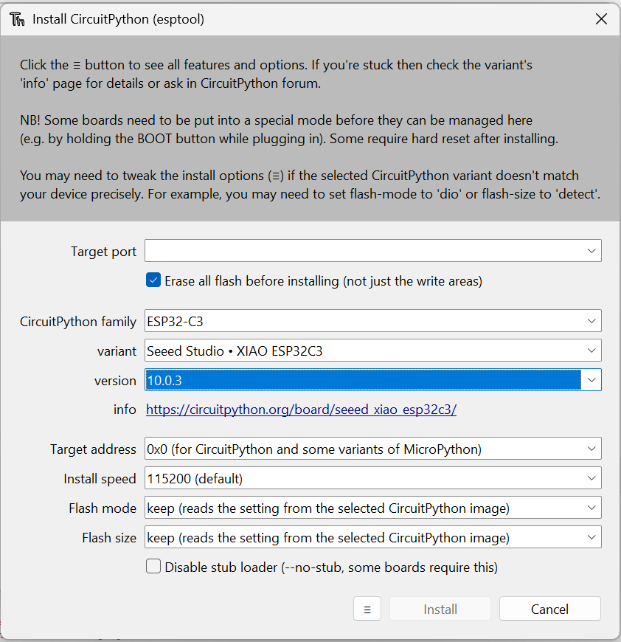
- Can now interface with device by selecting correct interpreter and port from bottom right of Thonny
  - 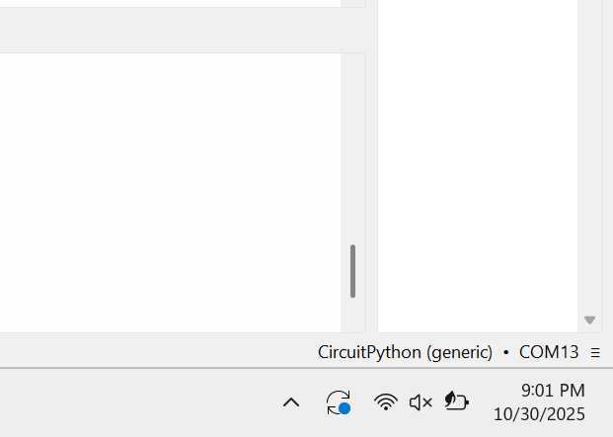
Libraries:
- Non default libraries need to be added to device lib folder. Libraries can be downloaded as zip from circuitPython website or maybe Seed (CHECK?)

